Thank you for supporting our health outreach after Hurricane Florence to Vulnerable Populations!
March 12-16, 2019
Our service learning health outreach for Hurricane Florence recovery was highlighted in the NC Health News (April 29, 2019) – by a reported who did some great interviews on community work in Wilmington, NC https://www.northcarolinahealthnews.org/2019/04/26/creative-community-workers-support-those-recovering-from-eastern-hurricanes/
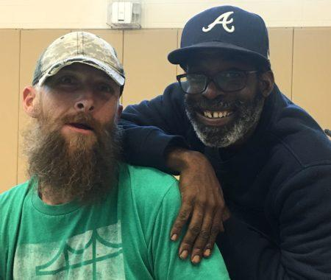 | Creative community workers support those recovering from Eastern hurricanes - North Carolina Health News  www.northcarolinahealthnews.org  “Depression, asthma, diabetes and hypertension often become uncontrolled related to the stress and environmental effects of hurricanes and flooding,” Jean Ann Davison, a family nurse practitioner and clinical associate professor at the UNC-CH nursing school, wrote in an account of the trip.. “And health outcomes can be impacted for years during the recovery period.”

Additionally, our UNC SON allowed our students to “take over Instagram” each day we did a different health outreach – March 12 -16, 2019.
I wanted to take a moment and say thank you to so many supporters and community partners that supported our team to do this outreach. Your support not only helped those recovering from Hurricane Florence in Eastern NC, but allowed our inter-professional students to grow in culturally sensitive, compassionate care. The impact has a ripple effect to allow our students to gain knowledge, skills and attitudes to achieve a “Global Mindset” to practice health equity locally and globally https://sonportal.unc.edu/curriculum-2019/the-carolina-core/
Here is a summary of our spring “break” service learning trip:
Our outreach team wants to thank UNC School of Nursing and Alumni Association, Alpha-Alpha and Nu Omega chapters of STTI, ANS students of UNC and UNCW, Christ United Methodist Church and United Methodist Committee on Relief (UMCOR), Global Med training, Compassion Med International, all the individual supporters and our Community Partners! We had an amazing team – pictured below and made an impact working with community partners in Robeson, New Hanover, Pender and Sampson Counties of Eastern NC.
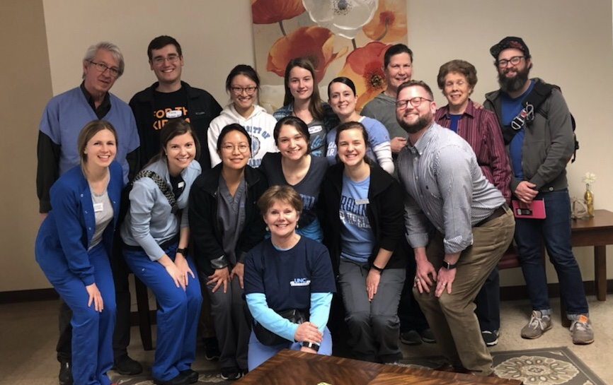
Here is a short summary of our outreach:
March 12-16 Hurricane Florence Recovery – Health Outreach to Eastern Areas of N.C with a focus on vulnerable populations.
Health outreaches were held at the below locations; our team saw over 200 participants for health screenings. Common same day referrals to ER or urgent care included blood sugars over 600 and blood pressures very elevated but not having symptoms of chest pain. Many stated they had symptoms and a history of anxiety and depression. They stated the hurricanes and flooding have made it worse and created a loss of hope – that was especially noted in Burgaw.
Tuesday evening dinner and congregational health screening at Branch St United Methodist Church (Lumberton). Branch St UMC was a congregation, predominately Lumbee Indian, that was completely flooded during Hurricane Matthew and is rebounding from that destruction. We held a health fair prior to a dinner- program and identified a woman with a blood sugar over 600 that was sent to the ER. The woman had shared due to her Medicare Rx plan, she had hit a “donut hole" and could not afford buying her insulin or the glucometer strips. She told us had we not checked her blood sugar she may have ended up in an accident as she was leaving in the morning to drive out of town to visit grandchildren.
Later that evening we heard at the community dinner how the hurricanes (Matthew, Florence and Michael) have devastated so many areas of Lumberton and residents cannot afford flood insurance or the cost of rebuilding mold infested homes. Many felt the floods could have been prevented by better infrastructure, especially along the railways.
Wednesday 9:00am to 6pm – Robeson County Church and Community Center - RCCCC (Lumberton). RCCC Chas supported the community for over 50 years; it too had been flooded by Hurricane Matthew and had to rebuild but, immediately after Mathew RCCCC was still providing community emergency assistance out of a shelter! This year alone it has provided 12,660 households with food assistance, over 500 families with rent/utility assistance and over 2,000 with medical/infant supplies. There is great need in Robeson County, with the worst health rankings for health outcomes in NC (ranked 100 out of 100 counties in NC www.countyhealthrankings.org/app/).
We tracked screening measurements at each outreach for body mass index (BMI), blood glucose, blood pressure, tobacco use, and depression and found high numbers of positive screens – especially in Lumberton. Fortunately, we had great community partnerships and were able to get same day appointments and urgent care visits with South Eastern Community Health Center, Robeson County Health Department and Robeson Health CHC. We also worked with faculty from UNC Pembroke. Everyone offered evidence-based health promotion and community services in English and Spanish.
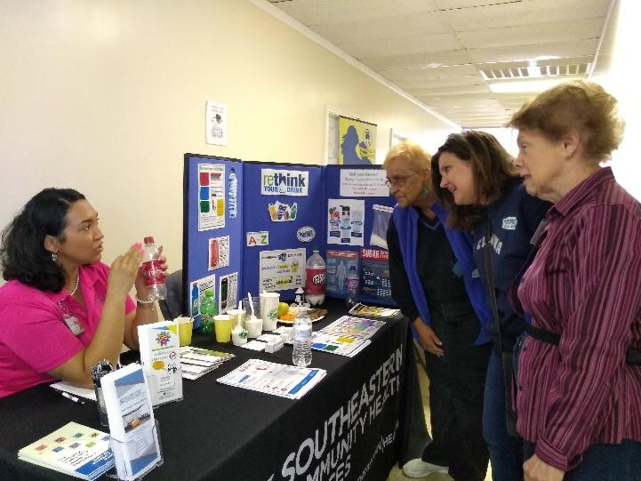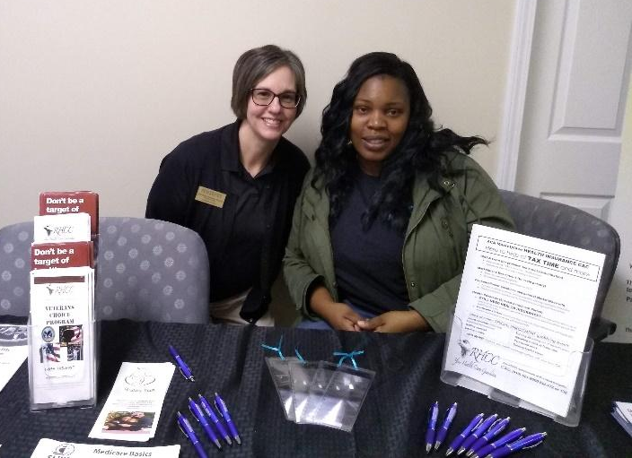
Thursday – Anchor ministry for unsheltered/homeless – a community luncheon with health outreach at Grace UMC in Wilmington. The Anchor provides a community lunch to the unsheltered along with a “home” for those recovering from hospitalization called hope recuperative care . At this outreach we partnered with faculty and students from UNC Wilmington – that helped with donations of food, clean socks and toiletries- UNCW SON News . Additional highlights of working with the Anchor including learning about “Switchin Gears” a bicycle shop that restores bikes to allow a healthy way of transportation for the low income. This outreach was highlighted in NC Health News .
Friday – Community Supper and health fair 4pm to 7pm at St. Joseph’s Church and Catholic Charities, Burgaw, NC. Burgaw in Pender County was one of the hardest hit by Hurricane Florence and also was the most isolated; many in the community discussed feelings of despair. Working with Catholic Charities, Pender County Health Dept. and outreach workers from the local community health center, we were able to feed participates, provide screening and health services and do immediate referrals to local agencies. One pastor stopped at the food pantry to pick up food and supplies for his congregation, only to discover that his blood pressure was dangerously high and needed immediate follow up!
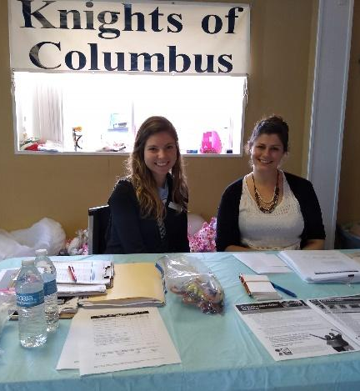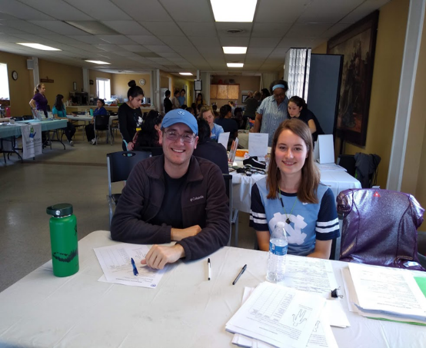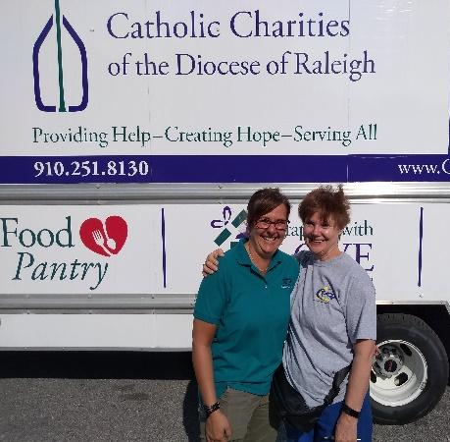
Saturday – 7am to 1pm – food pantry and health fair at Episcopal Farmworkers Ministry in Dunn, NC
Our last outreach began before sunrise – at the Episcopal Farmworkers Ministry food pantry. During Hurricane Florence, they ministered to farmworkers who were flooded and isolated with food, water and transportation to safety. This last outreach “sparked joy” in both the participates and team!
Here is a link to some of the team’s photos: https://photos.app.goo.gl/mhJVyJWdAo7QDb9P6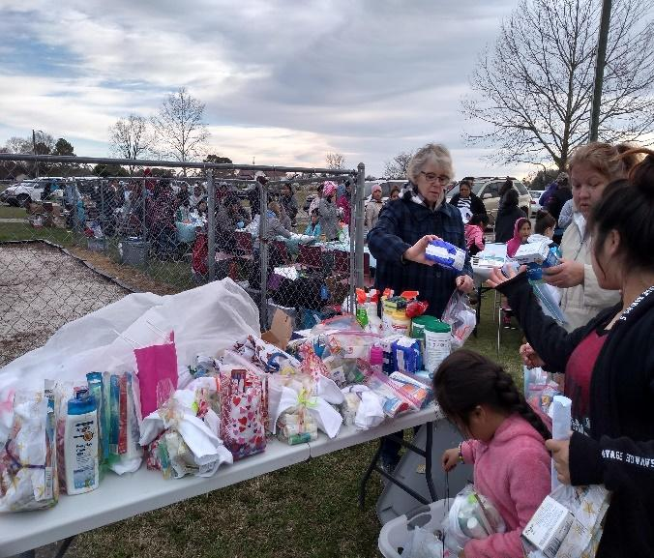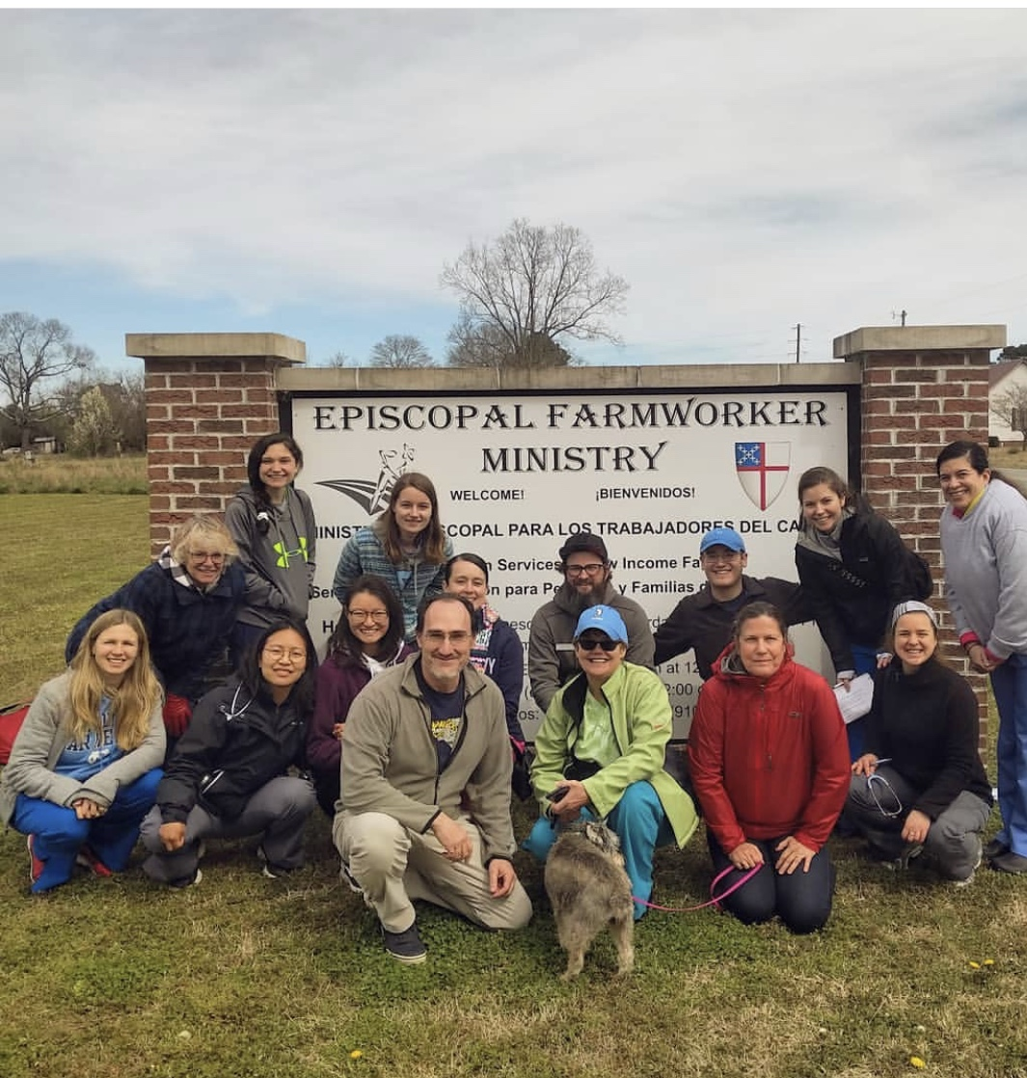
For further information or presentation, please contact Jean Davison, DNP, FNP, Clinical Associate Professor and Service Learning Course Coordinator. Davison@unc.edu
I will also be presenting Service Learning - Hurricane Florence Recovery - a Health Outreach to Vulnerable Populations — on 9/20/19 at NCNA Annual Convention

