Compassionate Care to Vulnerable Populations During COVID 19 Public Health Response
Service Learning 609.001 Spring Break Trip March 10 – 13, 2020

Our Service-Learning Team of students and volunteers met four times in evening classes in January and February 2020 to prepare for our spring break community health outreach to vulnerable populations. Our classes focused on understanding the communities we would serve with a focus on health equity, health disparities, risk behaviors that affect health outcome, social determinants of health such as education, income, healthcare and food accessibility and housing. Additionally, we examined our own cultural beliefs and personal bias. For these health outreaches we focused on primary and secondary prevention to include the US Preventative Services Task Force recommended screenings with referrals for abnormal results.
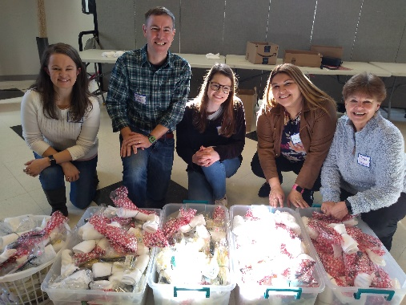
On Martin Luther King Day, we were able to make over 500 hygiene gift bags to pass out during our outreaches supported by donations from Christ United Methodist Church and the Hampton Inns.
Our health outreaches focused on working with well-established nonprofits that address food insecurity in communities that have been affected by hurricanes in Eastern NC and are still in recovery phase. We planned the health fairs to go on during food pantry distribution times and lunches. We worked closely with the local health departments and community healthcare providers to screen for health risks (such as high blood pressure, diabetes, obesity, depression and other risks such as lack of access to care) and provided follow up care and health information to include information and screening for coronavirus COVID19.
Our community outreaches were to:
Robeson County – which is the poorest county in the state and ranks worse for health outcomes in NC (100 out of 100 Counties) compared to Orange County that ranks 2nd. An estimated 44% of children live in poverty. This county is culturally very diverse with four major populations to include Lumbee Native American, African American, Hispanic and Caucasian. The 2018 Robeson County State of the County Health reports recovery from Hurricane Matthew and Florence is still on going with a focus on reducing health disparities and improving behaviors around obesity, diabetes, cardiovascular disease, tobacco use and substance use. Our outreach was with Robeson County Church and Community Center (RCCCC) that provides approximately 100 boxes of food each day to feed families in need along with other services such as prenatal vitamins for women of childbearing years, diapers and helps with utilities.
Wilmington/ New Hanover County Homeless working with the Anchor and Meg McBride, of the Tri-County Homeless Interagency Council and Director at Hope Recuperative Care. There were 431 homeless individuals in the Cape Fear area in a 24- hours point in time count of shelters in January, 2019; due to housing shortages since Hurricane Florence there are many more that were not accounted for. The unsheltered are a diverse group, including single people, families with children, veterans, and individuals with physical and mental health issues. Meg McBride has shared with us that a large part of her work has been in helping many apply for disability services to include mental health services. Our outreach included the Welcome Table – a served free lunch along with visiting and learning more about Hope Recuperative Care and the Switchin Gears bicycle program that helps with bicycles for children and adults for transportation. We also helped with a food pantry – Mother Hubbard’s Cupboard in Wilmington, NC that provides food boxes that include fresh vegetable and frozen meat to over 100 families a day.
NC Farmworkers – there are over 80,000 migrant and seasonal farmworkers in NC during agricultural season. We had planned to do a health fair for over 100 families at the Episcopal Farmworkers Ministry in Dunn, NC on Saturday 3/14/20. Due to the COVID 19 State of Emergency we canceled this event to prevent social gathering and instead sent flyers in English and Spanish along with supplies to help in preparation. For migrant workers in NC, COVID 19 may be hard to avoid due to crowded living and working conditions. Bandannas and long sleeve shirts were collected to protect against pesticides and sun and hygiene kits were prepared to include sunscreen and mosquito repellent to be distributed to the workers. The bandannas can also be used as a face mask to protect against COVID 19.
All the low-income families and communities we served over spring break are considered vulnerable populations with increased risks for health disparities and poor health outcomes; these risks also put them at increased risk for morbidity and mortality associated with COVID 19. Common concerns with low income, unsheltered and farmworkers especially related to COVID 19 includes:
- Lack of health insurance/inability to become insured; Lack of access to health care;
- Lack of childcare; Lack of adequate education and nutrition programs when schools close;
- Lost work and lost wages and the serious consequences that can follow, including inability to pay for basics like food, rent, and utilities, and the results of that inability, including hunger, eviction, and/or lack of basic services.
- Lack of unemployment compensation; Lack of paid sick leave; and even for those with paid sick leave, pressure from employers or from the reality of poverty to continue to work despite illness.
- Unsanitary, crowded housing and the risk of losing housing due to job loss.
- Stress and anxiety, and lack of mental health resources.
- For farmworkers there is also uncertainty regarding the H-2A agricultural guest worker program and the closing of US consulates’ visa processing along with language barriers.
COVID 19 Timeline during our Spring Break Health Outreach: March 10-13, 2020
With my background in public health and epidemiology, I knew COVID 19 would be a public health concern, especially following the universities’ spring break and students’ travels. Early on our hurricane “recovery” quickly turned into disaster preparedness and response to COVID 19 – novel virus. From the CDC website I printed pictorial advice in English and Spanish to inform the public, and bought multiple bottles of hand sanitizer, gloves and masks for infection control to protect our team and the public. My husband, who is a physician and I set up a screening station outside, before anyone entered the buildings, asking each participate if they had fever, cough, cold or flu like symptoms and then took their temperature with a forehead scanner. Each participate was given an application of hand sanitizer to clean off their hands, instructions on how and when to wash their hands and information flyers on COVID 19 on symptoms and ways to prevent transmission.
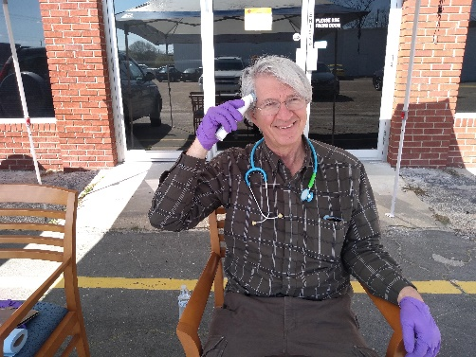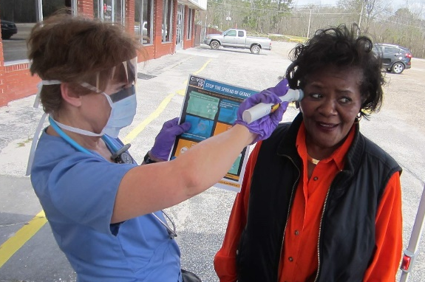
At most locations we worked with the organizations to avoid large gathering allowing only 10 participants to enter at a time. Many of these food pantries provide over 100 boxes of food a day to feed a family for a week, so their role is vital in the community and increases in disasters. 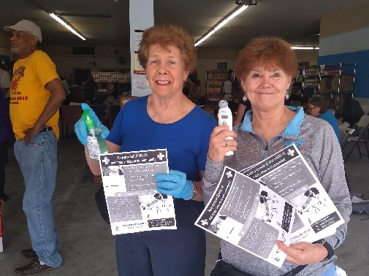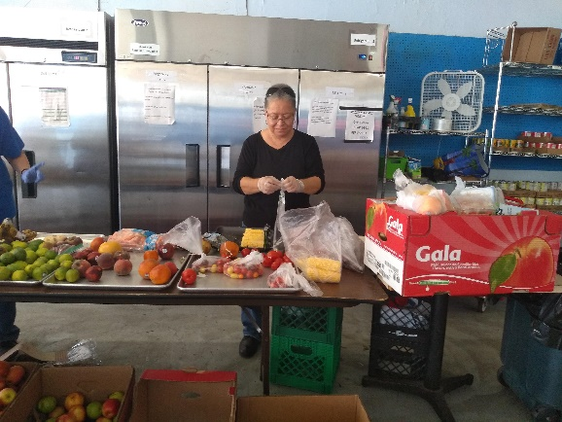
In the beginning the focus of our state (NC) was on a containment mode (preventing community transmission by tracking and isolating all known contacts) and on 3/10/20 the focus became a mitigation mode (controlling community transmission). At all the health outreaches we limited the number of participants entering at a time and had a booth for the local health departments (Robeson County and New Hanover to provide more local information. Pictured below is New Hanover and Robeson County Health Departments set up to work with our service-learning team.
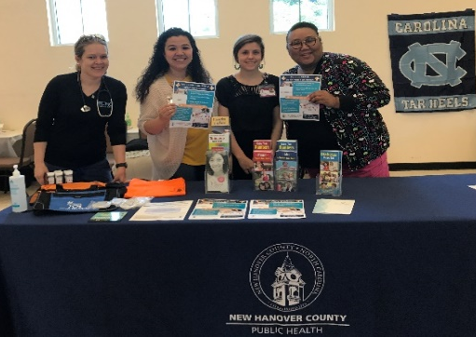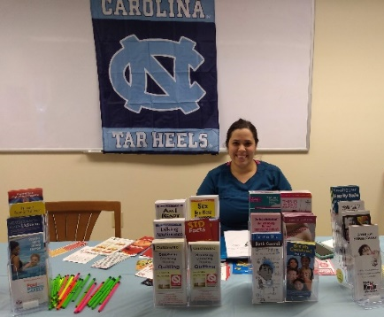

March 10, 2020 Tuesday afternoon - Gov. Roy Cooper declared a State of Emergency for North Carolina the day after five more cases were presumptively confirmed in the state. On Tuesday, our day began at UNC Pembroke with a tour of the Culture Center followed by setting up at RCCCC and a small gather and health outreach at a Lumbee church on Tuesday evening. We screened congregational members for cold/flu like symptom (all were symptom free) – and did a presentation on COVID 19 using our handouts and information provided by the CDC. The majority in attendance were over the age of 65 years old, most had HTN and/or diabetes and so were considered the most at risk.
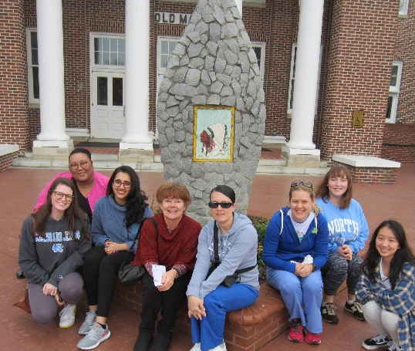
Wednesday, March 11 – Our Robeson County Church and Community Center health event was 9 am to 5:00 pm with everyone screened for fever, cough or respiratory symptoms prior to entering the building. We screened over 30 and had 4 that did stated they had “cough/cold symptoms” and/or had low grade fever that we suggested they follow up with the local health department or primary care provider and did not enter the health screening or building. RCCC provides food boxes to feed a family of 4 for a week; typically serving 100 families a day. All were provided food packages to go. We also talked with the director on ways to continue providing services while protecting the workers and volunteers. Extra hand sanitizer, gloves and masks were left for the workers who handed out the food packages.
Our community partners provided health information, screening, and same day appointments for those in need of services, especially those that had uncontrolled chronic diseases such as diabetes and high blood pressure. Having our community partners there made screenings follow ups accessible.
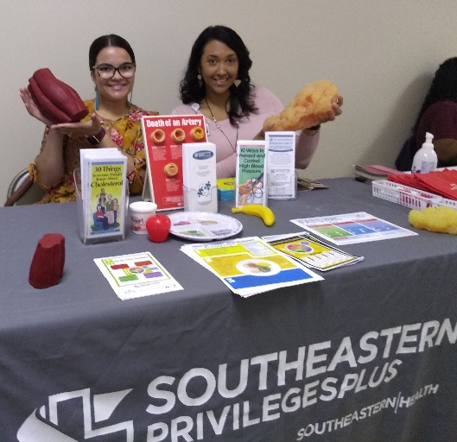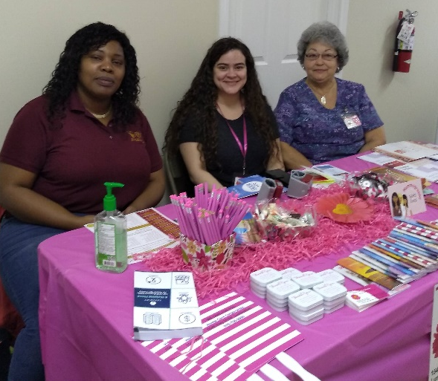

3/11/20 the World Health Organization declared COVID-19 a pandemic. I contacted the Episcopal Farmworkers Ministry to discuss canceling our large health fair on Saturday morning (March 14th) as we expected more than 100 families in which the gathering outside would be difficult to screen individuals who may have symptoms of fever, cough etc and expose others. A discussion took place with our team, the Dean of our School of Nursing and the Episcopal Farmworkers staff with the final decision to cancel the event at this time and inform the public and community organizations who would be there.
At the end of our RCCCC health fair, UNC announced it was extending its spring break until March 22, then moving classes to an online format. The recommendation was for students away not to return to campus. Students expressed anxiety over what would happen to their labs, clinical and for those who lived in rural areas without internet broadband, would their learning/grades suffer. All students wanted to continue the service learning, small contained health outreaches scheduled with the food pantry and meals the next two days.
Wednesday night 3/11/20 – President Trump suspended travel to Europe (excluding Great Britain) and quarantine for those returning. Some students stated they had friends trying to get to England to fly out. Our evening team debriefing focused on both our personal anxieties of finishing the spring semester’s clinicals and the concerns around those we were serving this week. Knowing that more than 40% of children live in poverty in Robeson County, what happens when schools close for those that receive free or reduced lunches? What happens to families who work part time jobs without benefits when they can no longer go to work? What happens to families that rely on the community services such as these food pantries if they too close?
Thursday 3/12/20. We left at 7am to drive to Wilmington to set up for the Welcome Table community luncheon focused on homeless/unsheltered gathering for a community meal. This community outreach began with a discussion with our community partners – New Hanover County Public Health Department, The Anchor and Grace United Methodist Church pastoral staff and those preparing the served meals. The discussion focused on the moral dilemma of providing a hot community meal to those who are hungry and often socially shunned, vs protecting the public and those at risk from COVID 19. My husband and I suggested we would greet all participate at the door with hand sanitizer, screen for symptoms of respiratory infections or fever and provide the lunch to go for anyone who was “sick”. One woman did have a fever of 99 and had stated she had been coughing. She was provided a mask, a meal to go and was able to get an appointment in the afternoon with a primary care provider.
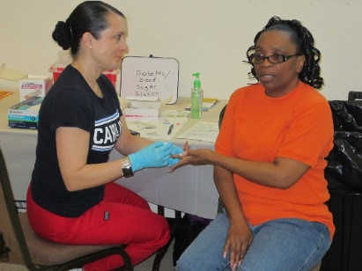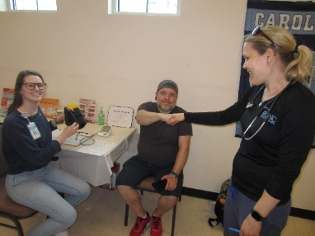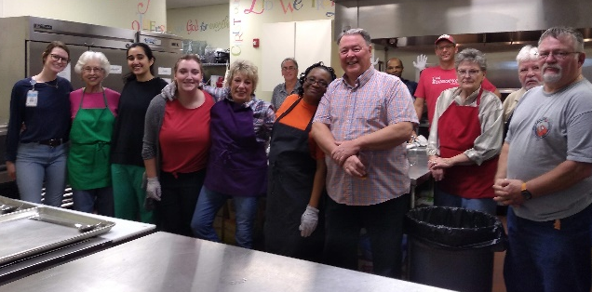
After the community luncheon we screened 10 individuals for obesity, HTN, DM, substance use and depression. All had at least one positive screen, one gentleman had only one lung and had a mask for personal protection and one female’s blood pressure required immediate follow up, in which she was able to get a Rx and treatment that same day. A social worker was available to help with navigation for health services for low income and homeless. We provided socks and hygiene kits to all and New Hanover Public Health Educators provided bags with t-shirts and information on services and COVID-19. After the community welcome luncheon, we visited the Anchor’s “Switchin Gears” that supplies repaired bicycles to those in need of transportation and we took a guided bicycle tour of Wilmington.
On Friday, March 13, we ended our spring break service learning health outreach with visits to Hope Recuperative Care and Mother Hubbard’s Cupboard in Wilmington. At Hope Recuperative Care students helped with the community garden and built a chicken coop along with watching a presentation from a famous chef on how to prepare nutritious low-cost meals. In the afternoon myself, my husband and a nurse volunteer helped screen clients entering Mother Hubbard’s Cupboard Food Pantry, one at a time to pick up the food boxes. To end our week’s work – several of us took a long walk on Wrightsville Beach and contemplated what would our new state of emergency look like in the coming weeks.
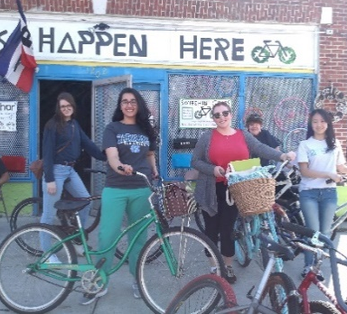 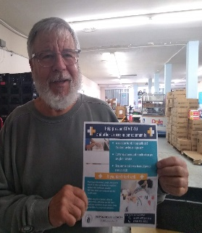 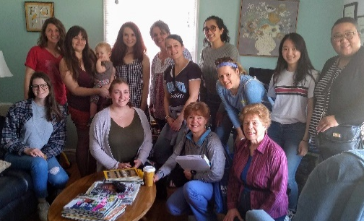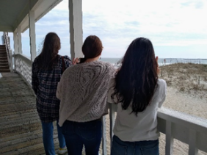March 13, 2020 Friday – President Donald Trump on Friday declared the coronavirus pandemic a National Emergency. This declaration allowed CMS and every hospital to go into emergency preparedness plans. Also, during that presidential news coverage, they discussed increasing diagnostic testing and removing restraints to testing and beginning social distancing.
COVID 19 Timeline Six Weeks Post Service Learning to Vulnerable Populations
3/21/20 – text from Alert Carolina: Emergency Notification: UNC Community Members Test Positive for COVID 19.
3/25/20 the second death in NC was a Sampson County resident who was a 37-year-old male with high blood pressure and obesity. Sampson County was where our NC Episcopal Farmworkers health fair was to be held, that we canceled due to the need to social distance.
3/27/20 Governor Cooper Issues Statewide “Shelter-in-Place” Proclamation; to begin Monday 3/30/20 to protect against the spread of COVID-19.
4/7/20 COVID 19 In the US - Total cases: 374,329 with Total deaths: 12,064
NC Governor Cooper extends the “Shelter in Place” until the end of April. Dr. Mandy Cohan states the social distancing is working. Presently in NC there are greater than 3,200 positives confirmed COVID 19 cases, 55 deaths and 354 severe cases that are hospitalized. In NC over 445,100 adults have filed unemployment claims.
4/10/2020 – In NC, a month after Governor Roy Cooper declared the state emergency, there are more than 4,500 confirmed cases, 330 hospitalized with severe disease and more than 80 deaths related to COVID 19.
4/12/2020 – In the United States a month after President Trump called a national emergency, the US confirmed cases has surpassed 500,000 and the US has passed all countries in deaths: more than 21,000 people with the coronavirus have now died.
4/25/2020 – In the US confirmed cases are more than 953,000 cases and deaths toll tops 53,000. More than 26.4 million Americans have filed for unemployment.
In NC cases are greater than 8,700 cases and 308 people have died with 465 hospitalized. More than 730,000 unemployment claims have been filed since March. The state is partnering with 3 medical centers – UNC, Duke and East Carolina to ramp up testing to better understand the true number of COVID -19 infections in our state but still is lacking testing supplies and PPE. Also, a statewide stay-at-home order has been extended until at least May 8, but Gov. Roy Cooper has laid out a three-phase plan for reopening businesses and social activities if data shows the virus is waning. Without a vaccine, the WHO states what governments need to do to safely lift lockdowns is test, trace and quarantine (per WHO spokeswoman Dr. Margaret Harris); that is moving back to a containment mode.
Reflections and Thank you
All our team of students, volunteers and community partners moved quickly from a hurricane recovery mode to a disaster preparedness and response mode for COVID 19. Reflections from the students and myself included a concern for the vulnerable populations we served, especially with the increase risks of COVID 19 and unemployment but also wanting to help and assist as much as possible. We all advocated for PPE and helped with making masks and educated the communities on COVID 19. Many of our students and volunteers that went on the trip are back providing healthcare to COVID 19 patients, helping with telehealth and with our state’s research efforts to decrease the spread of disease.
The food pantries ( Robeson County Church and Community Center and Mother Hubbard’s Cupboard ) have doubled the amount of food boxes passed out to households each day from 100 to 200 with providing safe social distancing by having “drive up services”. The “Welcome Table” has turned to food bags passed out to those in need, especially the homeless/unsheltered with the closing of churches due to COVID 19 but sick patients needing a safe home to recover can still go to Hope Recuperative Care. The Episcopal Farmworkers Ministry and NC Farmworkers Project outreach workers are visiting the farms to make sure information on COVID 19 are posted and education is in English and Spanish. We even made a short YouTube video on how to protect yourself and make a face mask in English and in Spanish https://youtu.be/ywux7tvVbco
It’s easy to become discouraged and feel hopeless when you see risings deaths and unemployment due to COVID 19 and know that the vulnerable populations we served have even greater risks for poor outcomes, but its encouraging to see our students, volunteers and community partners rise up to the challenge of providing compassionate care to vulnerable populations during this COVID 19 pandemic.
There are so many who made our outreach possible and continue to impact the lives of so many within their communities. A special thank you for donations and volunteers goes out to the UNC School of Nursing, Carolina Center for Public Service, Alpha-alpha STTI, Christ United Methodist Church that not only helped support this outreach but continues to provide volunteers to help fight COVID 19 and provide lunch boxes for the children in our community that normally receive free or reduced lunches while in school.
Our community partners all deserve an award for not only hosting our health outreaches but also for the tireless outreach they continue to provide without ceasing – Robeson County Church and Community Center, Branch Street UMC, Chestnut Street UMC, Grace UMC, the Anchor, Mother Hubbard’s Cupboard and the Episcopal Farmworkers Ministry along with the Robeson County and New Hanover Health Departments that are in the frontline of the COVID 19 pandemic. And most importantly our team of students and volunteers that make me proud to be a Carolina Nurse!
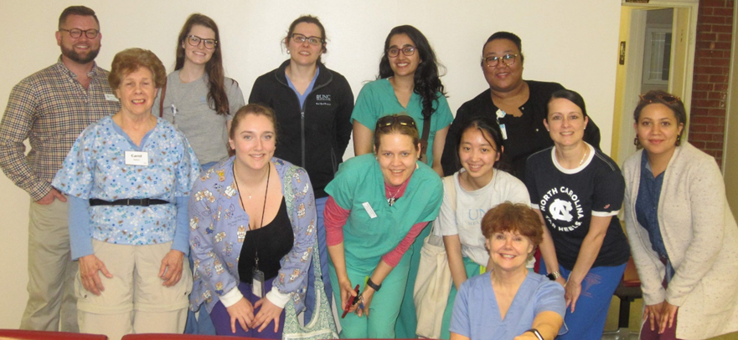
Photo album to outreach: https://photos.app.goo.gl/q5UJSEorhnLKhUo67 and
instagram https://www.instagram.com/stories/highlights/17867472703659058/
For more information – contact davison@email.unc.edu
Jean Davison, DNP, FNP-BC, Clinical Associate Professor at UNC- Chapel Hill

